Bellwork for the week of Sept 25-29

9/25:
Grammar textbook pg. 394 Exercise 3
Must come into the classroom to see the bellwork.

9/26-9/27:
M.U.G. Shot 5
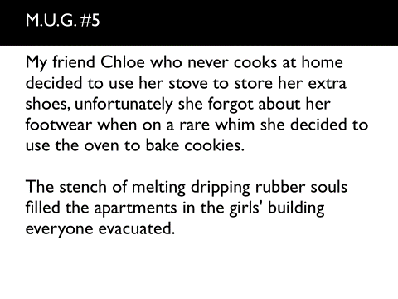

9/28-9/29:
Lit Term 5 Video:
https://www.educreations.com/lesson/view/litterm5tpt/9218780/?s=PoPOrB&ref=link
Watch and take notes.

