Bellwork for the week of 9/18-9/22
9/18-9/19:
M.U.G. Shot 4
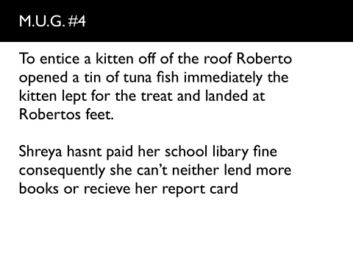

9/20-9/21:
Lit. Term 4 Video
https://www.educreations.com/lesson/view/litterm4tpt/9218757/?s=uGQ49O&ref=link
Take notes!

9/22:
Grammar textbook pg. 394 Exercise 3
Must come into the classroom to see the bellwork.

